Earthquakes

Define the term earthquake

- List three pieces of evidence that may indicate an earthquake was or has taken place.

- Some journalists, when reporting on earthquakes, use both the location and the depth of an earthquake to describe the epicentre. Why is this incorrect? What advice would you give to allow them to be able to use scientifically correct language?

- Draw a line to match the type of earthquake to the correct image.
- The blocks of Earth move down vertically as the rocks pull away from each other. | A. 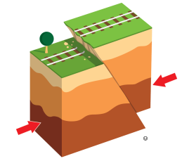
- The blocks move towards each other and one is pushed up and over the other. | B. 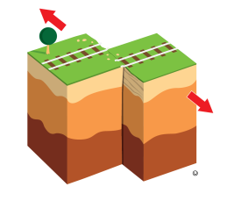
- A vertical fault and the blocks of Earth move horizontally and slide past each other. | C. 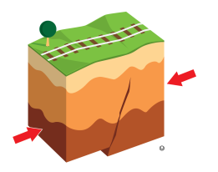
- The blocks of Earth move towards each other but the fault doesn’t completely rupture. There is no evidence of an opening but there may be buckling of the earth or objects on the surface. | D. 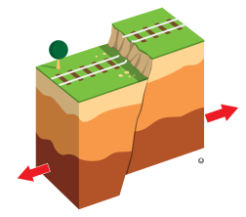
- Explain the meaning of the following statement using your science knowledge:
‘When the trembling stops the disaster is only beginning’.

- Explain how knowledge of earthquake activity is used by communities.

- Complete the crossword about earthquakes.
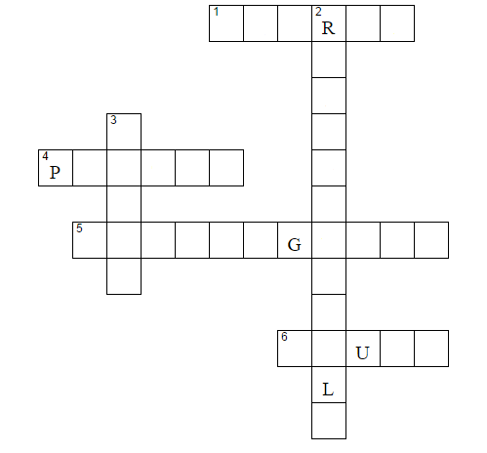
Across
- Earthquakes release this from the centre of Earth
- Where most earthquakes occur.
- The device used to record information about an earthquake.
- The Earth plates grind together along this.
Down
- How earthquakes are graded.
- Released energy is in the form of seismic

